

r^CH:4<~<Ur

The Day  
Nazi

Germany

Died

An Autobiography By

Beate Wilder-Smith

An Eyewitness Account of the  
Russian and Allied Invasion of Germany  
(iff!

mflSTER BOOKS  
A DIVISION OF CLP

MASTER BOOKS

San Diego, California 92115

Copyright © 1982 Beate Wilder-Smith

Published and Distributed By

MASTER BOOKS A Division of CLP Publishers P.O. Box 15666 San Diego, California 92115

Library of Congress Catalog Card Number 82-71148 ISBN 0-89051-083-0

ALL RIGHTS RESERVED

No part of this publication may be repro­duced, stored in a retrieval system, or trans­mitted in any form or by any means—elec­tronic, mechanical, photocopy, recording, or otherwise—without the express prior permis­sion of Master Books, with the exception of brief excerpts in magazine articles and/or reviews.

Cataloging in Publication Data

Wilder-Smith, Beate

Day Nazi Germany died, The.

1. World War, 1939 - 1945 — Personal narratives, German. I. Title.

940.5482 82-71148

ISBN 0-89051-083-0

Printed in the United States of America

Contents

About the Author **5**

Preface 7

Parti. Pre-World War II **15**

1. Conditions in Germany **17**

Hard years of the great depression . . . How father helped combat the misery . . . How and why the Ger­mans fell for Hitler politically, spiritually, economically

1. Nazi Policy **27**

Darwinian evolution and racial policy . . . eradication of the handicapped, the Jews, and other races , . . bes- tialization of the German people

1. Kraschnitz 33

Practical liquidation of the mentally handicapped, with its implications

Part II. World War II 37

1. Gollnow 39

Happy childhood interrupted by the outbreak of World War II . . . Father's ministry under Nazi rule . . . Spies and informers in the home and school . , . Jewish friends and refugees in our home . . . Russian soldiers and the Lutheran clergyman . . . Suspicious letter and the Secret Police

1. War Service on the Eastern Front **51**

Trench digging by children and old people before the Russians . . . Housing conditions . . . Mail censorship Acute epidemic breaks out . . . Father seriously ill . . . Reunion at home . . . Refugee treks and trains , . . Refu­gee care by our family and others . . . Musical and cultural evenings—in spite of war

1. Flight Before the Russians 63

Midnight evacuation of our town . . . Drunken SS sol­dier attacks father . . . Evacuation train miraculously diverted to follow the route needed . . . Stolen suitcase . . Remarkable dream and its consequences . . . New home constructed out of wall maps . . . Curing the lo­cal tensions . . . Village women try to avert all-out bat­tle . . The British are coming! . . . Fighting—first con­tacts with the British . . . Father helps select new mayor

Partlll. Post World War II 83

1. Grandmother and the

Russian Occupation 85

New type of poster: “Who am I?” . . . Grandmother's Silesian country home . . . Frustrated pharmacist . . .

The Russians are coming! ... 40 women and children encounter hoards of plundering Russians . . . Night of terror and Slavic orgies . . . Poles take over from the Russians . . . Last night on earth of a young Polish Offi­cer . . . Driven out of house and home by the Poles

1. Getting a Job 97

New tasks . . . Spiritual turning points

1. Frankfurt 101

Rebuilding the church physically and spiritually . . . Housing crisis in the bombed city . . . New building from old bricks ... A flourishing church in economic straits . . . Fellowship with American Christians . . . En­gagements to be married

1. Reliving Youthful Memories Ill

1980 journey to Poland and East Germany . . . Cultural shock in childhood hometown . . . Hospitality in a Po­lish motel . . . Whit Sunday with our East German friends ... A remarkable bill . . . Polish garages, cur­rency regulations, and the black market . . . Persecu­tion of Christians in East Block countries

1. Outlook 121

Could it happen again? . . . The TV program . . . How to avoid a recurrence

About

the

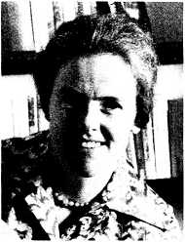

Author

Beate Wilder-Smith was born in Breslau, Germany, as second daughter of Reverend and Mrs. Wilhelm Gottwaldt. After the Abitur (university immatricula- tion exam), she studied music in Frank- furt/Main and Geneva, Switzerland, where she also studied French at the university. In 1949 she married Professor A. E. Wilder-Smith, internationally re­nowned scientist and lecturer on the problems of evolution/creation (Dar­winism and the alleged self-organization of matter) and consultant to NATO on drug abuse problems. Three sons and a daughter were bom in Germany, G.S.A., Norway, and Switzerland. The family moved 23 times—often to different coun­tries. Because the children’s schooling was so often interrupted by these moves, Mrs. Wilder-Smith often acted as a private governess for them in nearly all school subjects. Privately and in schools

she taught music history and theory, choir, and orchestra. She has helped her husband in the writing of his books and translated some of them—as well as other authors’ books—into German. Since her children left home for their school and university education in England and Germany, she regularly ac­companies her husband on his lecture tours and often helps with personal counseling, especially on the subject of marriage and family life. She col­laborated with her husband in writing the book entitled The Art and Science of Mar­ried Life (Kunst und Wissenschaft der Ehe). Her children are all in the medical sciences.

Preface

Church life in Germany is quite dif­ferent from that in the United States. Over 80% of the population belongs to the State Churches, Protestant or Catholic, and only a very small propor­tion of the people belong to Free Churches and other religious organiza­tions. The pastors of the State Churches are all well educated men who have studied at state universities and are also paid a decent salary by the state. But Europe’s difficulty in religious matters lies in the fact that by far the greatest percentage of the theology professors at the state universities are liberal and critical of the Bible. It is easy to under­stand why most theologians—after six years of this kind of study—are also liberal and consider anyone who is not liberal to be an ignoramus.

On the other hand, pastors of the Free Churches have usually received their

training at Bible Schools which are not state accredited, and many of these pastors have not even graduated from high school. There are some exceptions to this rule, but generally theologians trained in state universities in Europe tend to be liberal. The Bible Schools tend to be fundamental in outlook, although this position has been weakened in re­cent years. For this reason wide sections of the academic world in Europe believe that one can only believe in the reliability of the Bible if one is academically un­trained and ignorant, in spite of the fact that this is not true.

Throughout the Middle Ages and until recent times the ecclesiastics, the doc­tors of medicine, and the lawyers were the culture bearers in Europe. They were in the habit of inviting one another to their homes and gathered regularly in their homes to cultivate music, the arts, and sciences. This is the reason why so many of the European philosophers and scientists arose in those circles. Socialism and modern life have changed this. Therefore these three professions carried a much greater weight in the European past than they do in the pres­ent day United States. Because these three classes of society (which are con­sidered to be so important in Europe) are liberal, and the evangelicals do not have the same social and political status as they do in England and the (Jnited States, then gospel work in Europe is an entirely different proposition than in Anglosaxon countries—a fact which many American and British missionaries have difficulty in appreciating.

My own father, who is a minister of the Protestant State Church, became a Chris­tian at about fifteen. He studied theology because of his desire to help others find Christ. His professor was the well known liberal theology professor Bultmann who is famous for attempting to remove the alleged myths of the Bible. The reason father’s faith was not undermined during his studies was that he belonged to a Bible study group of young people who kept him on the right lines. “But,” father told me when I asked him about his stu­dent days,“It took me years afterward to get rid of the poison of the criticism of the Bible which had unconsciously crept into my thinking. By reading, praying, and discussions with scholarly Christians in the course of the following years I could straighten out the crooked parts of liberal university theology. My searching and researching made me capable of helping others with their intellectual problems with respect to the reliability of the Bible.” Years later father wrote two books on the reliability of God’s Word:

Science contra Bible? and Mistakes in the Bible?

In our childhood it was common for a minister of the State Church—as well as for other academics—to employ house­hold help and nannies. Our spacious house was always open to everyone at any time; so we needed help. Besides, people were glad to get jobs and to earn money. Christian parents liked sending their daughters into a Christian home at­mosphere where they were protected and could learn the know-how of Christian family life: to cook and bake, to sew and iron, and also some etiquette and culture and how to bring up children —an almost lost art today.

Only after the war when socialism took over with women’s emancipation, young girls preferred to work in factories, stores, or offices. They were taught that housework was degrading. The result is that a great part of the girls of today’s generation lack the know-how to build a family and home life. The consequences are devastating—50% divorce rates in Europe. Now the state tries—in its atheistic way—to teach young people sex education and the “rights" of the dif­ferent members of the family, with the obvious results.

The above notes on European history and customs may serve to help the

American reader to understand better some of the cultural details contained in­cidentally in the following account of the end of the Third Reich and the beginning of Germany’s attempt at democracy, with a very shaky religious culture as a base. Successful democracy can only subsist in a culture firmly based on God’s view of mankind.

"All history is bunk, ” said Henry Ford.

"Those who forget their history are doomed to repeat it. ” George Santayana

This applies to history of nations as well as  
to personal history.

Pre-World War II

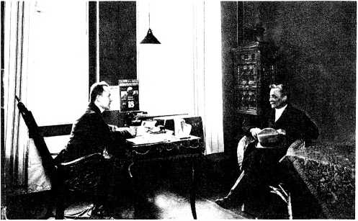

Unemployed came often to father's church office to ask for financial help and help with getting jobs and also for per­sonal counseling.

My father receiving such a one soliciting help.

My mother and my

great-grandmother.

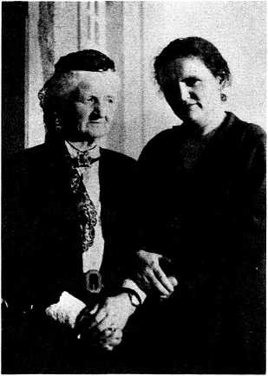

Chapter 1

Conditions in Germany

The years before the second World War were eventful times in Germany. Around 1929 there were hard years of depression and inconceivable misery, especially in the big cities. Thousands, even millions of people were without jobs, poverty- stricken, suffering from hunger and cold, and living in places unfit for human habitation, such as cellars, ruins, and backyards. Many died—others were stricken with diseases due to malnutri­tion and unhealthy and dirty dwellings. Crime flourished. People who suffer so immensely become bitter, frustrated, and rebellious. Many turned to communism for hope and the chance to fight for a bet­ter existence. Throughout these sad and unimaginably hard years, my father,

Wilhelm Gottwaldt, was a Lutheran pastor in one of the poorest workers’ quarters in Berlin. He spent many sleepless nights because of the people’s condition. How could he help? He knew these hopeless, despairing, aggressive people needed help, both spiritually and materially. He prayed for guidance, then began to put feet to his prayers. His first step was to initiate a warm room as a soup kitchen where poor jobless workmen and their families could get a free bowl of warm soup once a day. At the same time he gave a short Christian message. The Christians of the church who had a job paid for the food. Mext he started house visitations all over his parish. Every day father visited a certain number of people personally, most of whom had never entered a church in their lives. He visited every family in the parish, house by house, upstairs and downstairs, hundreds of steps and stairs daily . . . crowded attics with no wallpaper, no heating, full of rags . . . dark cellars without light or windows, damp breeding places of infectious diseases, dirt, and severe poverty. Gradually father’s love won their con­fidence. They felt at liberty to air their complaints, tell him their sufferings, their needs, their problems, their fears, in an effort to help them find jobs, dwelling places, money, and medicine, he went from one government office to the other, interceded with the wealthy, and shared with the Christians on behalf of the needs of these people. The Christians in his church prayed with him about all the special problems. He told his members about these needs so they could par­ticipate in the blessing of experiencing answers to their prayers. My father witnessed to these outcasts of society that Christ and His followers loved and cared for them, even if society as a whole did not. My dear mother often went with him on these visits. She had a warm and gentle heart, open and ready to help everybody who suffered or was de­pressed. After a while my parents became so respected by these poor peo­ple that nobody would ever have dared to hurt them.

During these terrible years even the police were often afraid to risk going alone into the backyards and miserable quarters of the communist areas of Berlin . . . if they wanted somebody, they called their names from the streets or sent a group of armed policemen into the backyards. They were often attacked or shot at by these desperate, violent peo­ple. But father went everywhere—in the backyards or in the darkest cellars—and was never molested. I remember him tell­ing us years afterward that he regularly visited a poor invalid who suffered from tuberculosis. "He had lain for years in a dark stuffy windowless room in a cellar with damp, mildew-covered, concrete walls. A large piece of rag hung from the ceiling which served as a door. He lay there alone day after day, night after night, with scarcely anyone to look after him. A neighbor came each morning to bring him food. I used to feel my way down the dark cellar stairs, along the humid dirty walls, push the rag curtain aside, and search for the emaciated hand of my coughing, sick friend. There he lay, waiting each day for my visit ... for some words of sympathy, love, and con­solation. He became a Christian and was a wonderful testimony to others because of his patience and Christ-like character.”

My mother tried to help by giving jobless people jobs around the house, for which she paid and fed them. For a long time she employed a carpenter, Herr Niemann, for furniture repairs and toys for us children. After some months he changed from a bitter, frustrated com­munist to a kind, outgoing Christian who became an efficient witness for Christ among his old communist workmates.

You can well understand how in 1933, when Hitler promised work and bread for everybody and positive Christianity, he was elected by a majority of 3 to 1. From then on, Hitler promised, everything would change for the better: no more hunger, better housing conditions, a bet­ter life, work for everybody, and an end to all the indescribable misery—he prom­ised to make Germany a strong, unified, respected nation again. And what Ger­man did not cherish that wish?

Hitler immediately began to fulfill his promises: he created thousands—even millions—of jobs, by building freeways and armaments. It really seemed like a miracle; nobody was jobless, nobody was hungry. But what was the price? Didn’t anybody notice? The price was forfeited freedom, dictatorship, debt, and annihila­tion of the Jews: racism. The greater his success, the more impossible it became to get rid of him. He took over Austria with the “Anschluss,” absorbed Czechoslovakia, and then made a fool of Chamberlain at Munich. The German people were so sure that the West did not want war that they thought the West would appease Hitler to any degree. Hitler was successful in armament and diplomacy, promised positive Christiani­ty, and spoke a lot on Providence. If only the people had read Hitler’s perfectly clear statements in his book, Mein Kampf, they easily could have convinced themselves of his clear intentions to set up a world tyranny—under himself, of course—involving the liquidation of all Jews, together with the enslavement of all other races of “non-Arians.” His policy statements on these points are just as clear as the common policy statements enunciated by Lenin, Stalin, and the Marxists to set up a world order under their domination. The trouble is that the common people are too bent on the “dolce vita” to bother to read and pay at­tention. (Unfortunately, this also includes the modern generation in the West today.) In those days anyone who was not a party member could not hope for a suc­cessful career . . . making them think twice before listening to the party’s real goals. They stuck their heads in the sand and hoped for the best. As long as they had enough to eat at the moment and good prospects for the future, they asked no questions. The families of the few Christians who saw clearly did stand their ground, but had to be willing to suffer the consequences of resistance—which sometimes even led to the concentration camp. This was true even of the school children and young people who studied at the universities. This is discussed fur­ther in the chapter on Nazi Policy.

The Source of Democracy

In other countries, such as England

and America, the basis of democracy is directly related to the revivals under Whitefield and the Wesleys, all of whom taught that the Christian should seek the best for the country in which he lived, should respect his neighbor more than himself, and should bring forth the fruits of God’s Holy Spirit. This was done on an entirely personal man-to-man basis, with politics a distant second in importance. Of course, central Europe had an early revival under the reformers, particularly Luther. But Luther compromised himself with the princes and through them pro­duced the State Church, leading to the idea of the crown and the altar. This pro­duced “personal faith” on the basis of decree by the state. People became Lutheran or Reformed according to which prince or state church ruled over them. This idea was perpetuated by the fact that you automatically become a member of the state church at baptism and confirmation, followed by payment of church taxes. This is the case even to­day. If one asks a person if he is a Chris­tian he will too often answer: “Of course, I am a Lutheran [or Reformed]." They con­fuse church membership with faith in Christ. In his later years Luther was also a convinced anti-Semite—which did not help the spirituality of his reformation. Hitler was able to use this to justify his anti-Semitism. In contrast, Wesley and Whitefield practiced the biblical principle of a spiritual rebirth based on personal faith in Jesus Christ, followed by personal responsibility—independent of the state church. Wesley separated true conver­sion from infant baptism and citizenship. With the exception of Holland, the West Coast of Norway, and parts of Sweden, Europe has never experienced a nation­wide movement of the spirit of God which produced such fruits as the Wesleyan revival did. Europe always regarded the state in toto as the hand of God which was to be obeyed and never criticized. The leader of the state, whether King or Kaiser, was like the general of an army, the soldiers of which had to obey because it was God’s will to obey. Germany, as well as other countries, experienced many local revivals, but they never spread nationwide and were always hindered by doctrinal differences, such as infant baptism or conversion and the absolute unquestionable authority of the state, i.e., if the state commands murder in aggressive wars, even the Christians’ main duty is to support such a state unreservedly.

1 know of a case of a young Christian soldier who while in Russia during the war was ordered by his sergeant to slaughter men, women, and children in a

Russian village. This was done in retalia­tion for the poisoning of some of his men by the Russians. Years later—still trou­bled by his conscience—this soldier asked my husband, “Do you think 1 was wrong in slaughtering these people? I can still see in my memory one young mother in bed who had just given birth to a baby. I could not force myself to shoot her. So I ordered another soldier to kill the young mother and her child. Was I guilty or not?” He was under the delusion that he bore no responsibility, but that his superior alone was responsible. He had sworn the oath to obey unconditionally all orders given by the state under Hitler, and it would have been perjury not to have kept his oath.

It is this type of mentality ingrained in a nation which allowed Hitler and other dictators to come to power and rule. This attitude can never produce a democracy, but only dictatorship. Among the ls- lamics one finds exactly the same prin­ciples of authority, contributing to the fact that no democracies have arisen from Islam. When only a small minority of the people in a nation embrace the biblical principles laid down by White- field and Wesley, a democracy will not exist for long. Therefore, the most impor­tant work we can do to maintain peace, true democracy, and concord on our earth is teach and preach the New Testa­ment truths, as Whitefield and Wesley did, which for political reasons never took hold of central Europe on a national basis. The working classes in particular were never captivated by New Testament Christianity. Today the average person who has never known a Spirit-led and Spirit-filled life still behaves in a way similar to the central Europeans who elected Hitler and submitted to and sup­ported dictators. Even Christian ministries can deteriorate so far as to forget the fact that human flesh is capable of almost anything if the New Testament Spirit (as exemplified in Phil. 2 and 3) is neglected. Christian organiza­tions are also guilty of ‘‘toeing the party line” by dropping spiritual relationships or fellowship with other Christians on the command of denominational headquar­ters or other central leadership, thus forgetting that the human personality is worth more to God than anything else in this world, including any “Christian” organizations.

Chapter 2

Nazi Policy

One of the central planks in Nazi theory and doctrine was, of course, evolu­tionary theory—equally a central plank in Marxist doctrine today. The Nazis were convinced, as are Communists today, that evolution had taken place, that all biology had evolved spontaneously up­ward, and that inbetween links (or less evolved types) should be actively eradicated. They believed that natural selection could and should be actively aided, and therefore instituted political measures to eradicate the handicapped, the Jews, and the blacks, whom they con­sidered as “underdeveloped.” They wanted to raise the Nordic status of the German people by importing Scandina­vian girls to breed with the SS (Lebens- born E.V.). They wanted to create the German Herrenvolk to rule over the world. We Christians knew all about this later on, but at the start we did not. As

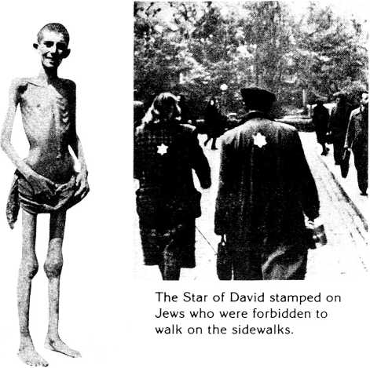

A prisoner in the concen­tration camp Ebensee (Austria).

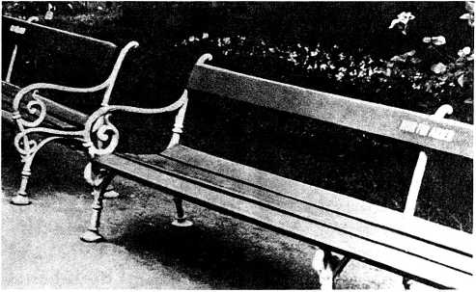

Park seats marked "only for Aryans.”

This lamp shade was made on Else Koch’s command from human skin taken from prisoners murdered to this end.

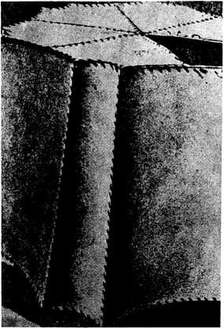

Else Koch, the comman­dant of concentration camps. She was a much feared inspector among the prisoners.

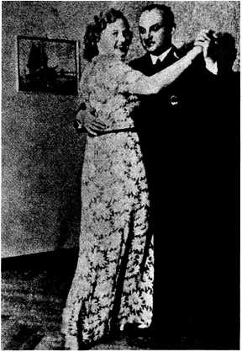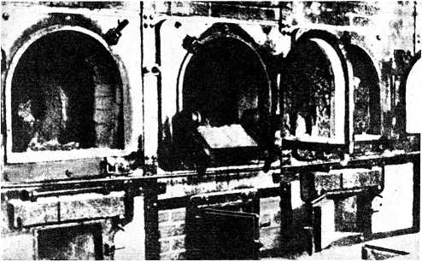

Cremation furnaces in the concentration camp Buchenwald.

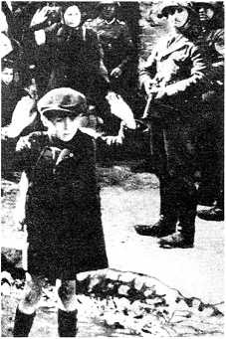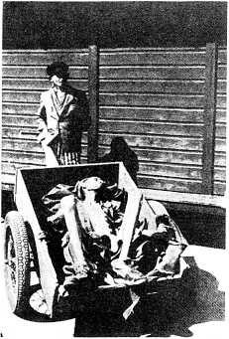

These Jews were driven forcibly from their bunkers in the Warsaw ghetto.

Human bones from a con­centration camp.

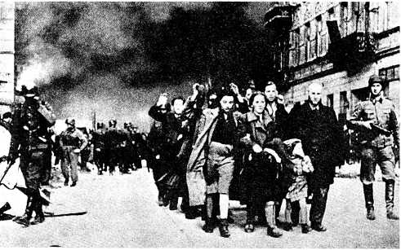

The destruction of the Warsaw Jewish ghettos.

A burning synagogue in Berlin.

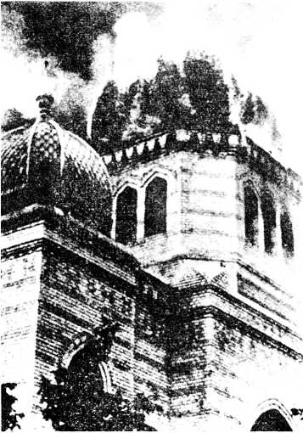

soon as Christians became convinced of the real purpose of the Nazi policy, resistance commenced. Hiding of Jews in houses became common, and thousands of both Christians and Jews were thrown into the horrors of the concentration camps.

Chapter 3

Kraschnitz

From 1933-1937 father was director of a training school for church social workers. He trained them according to biblical principles. Most of them were educated to work in churches, in hospitals, and especially in a big home for the mentally ill and mentally handi­capped. The home had been founded years ago by a faithful Christian nobleman, Graf von der Recke, and was situated not far from us in Eastern Ger­many. The poor handicapped people were cared for with Christian love, and our whole family regularly visited them in our free time. A number of them were true Christians. Some of them, in spite of their handicaps, were wonderfully gifted in craftsmanship, memorizing, or as ac­tors. We knew one young man who had memorized a whole Christian hymn book. If you asked him which song ap­peared on page 111, he would im­

mediately answer “What a Friend We Have in Jesus," or vice versa. He also knew his Bible verses. Another boy of about 12 years was a brilliant mathemati­cian who could solve the most com­plicated problems. There was an old countess who got up every day at a cer­tain hour, dressed up, and went to the sta­tion to take the parade with hundreds of soldiers and officers; she answered the salutes and went through all the formal regalia, although not a single man was there. She lived with her fantasy in by­gone days and imagined it all.

After a few years our family moved to a different part of Germany to take on a church in Pommerania. Soon we learned from good friends that Hitler’s regime wanted to get rid of the mentally defi­cient and mentally handicapped. They appointed a day on which the inmates of the institution had to pass various kinds of examinations: they had to solve mathematical problems, write down dic­tation, and answer questions—which were then graded. A commission decided that only the handicapped with the best grades could stay in the home. All the other sick who had not passed the test were loaded into a train, transported to a camp, and then gassed. The shocking thing was that many of the handicapped, when they were put onto that train, had a premonition that they were going to be slaughtered. Our friend, a nurse, who told us about these cruel happenings many years later, said that many of these handi­capped people were Christians and knew somehow where they were being taken. They had started to sing Christian hymns. The nurses were not able to hold back their tears because they loved these dear people. But the Christian handi­capped consoled them: “Don’t cry for us, we know where we are going. We are go­ing to heaven to be with Jesus." What courageous Christians many of them were! When my parents heard about these inhumane happenings, they were heartbroken . . . the attrocities were in­creasing.

World War II

Chapter 4

Gollnow

The greatest part of my early childhood I spent with my two sisters, Rosemare and Christiane, and our parents in a small Hanseatic town in the eastern part of Germany. The town, Gollnow, lay in the midst of beautiful pine woods and the old historic houses were surrounded by a picturesque city wall with four beautiful towers and city gates. A river used by merchant fleets during the Hanseatic times flowed along one part of the city wall. Our old historic vicarage, with its thick walls, lay near the stately gothic brick church—where father regularly preached—and the square cob­blestone market place. We lived in an old house with ten spacious rooms, all beautifully furnished with partly antique furniture and many valuable musical in­struments. Our family lived harmonious­ly and happily together and our parents surrounded us with love. They lived a real

Christian life and were an example to us.

In the midst of these happy years to­gether, World War II broke out. At this time most of the pastors were called up for military service. As father suffered from a valvular heart disease, he was not called up to war and could stay at home, but he had to look after the churches of other pastors who had to fight in the war —about twelve churches in the neighbor­ing area, besides his church in Gollnow where we lived. As there were no cars— all cars were used for the war by the army and not by private citizens—he had to travel by horse and coach or by sleigh in winter. Every Sunday he used to get up very early to get around to all the dif­ferent churches to preach. In winter he put on his thick heavy fur coat and cap and was wrapped in a warm blanket. Mother usually drove with him, as she was the organist in the various village churches, with their old mechanical pipe organs. She would hide her feet in a big fur foot warmer. When we were younger, we usually stayed at home with our nan­ny, as the thermometer sometimes sank considerably below zero. When a little older, we enjoyed going with them and helping to tread the old organ bellows. Then off they went with their coachman: the little horse bells ringing all the way through the silent thick forests in deep

snow. It was an enchanted fairy land with the beautiful snow-laced branches of the trees, the thousandfold glittering of the snow crystals in the sun, the stamping of the beautiful elegant horses, and the con­stant gentle jingling of the bells. The sleigh seemed to be flying as if weight­less. We always felt sorry when it came to a stop, but in the old cosy country churches, which in those times were never heated, we were always greeted by a friendly waiting crowd, eager to listen to God's Word. In spite of the Nazis, who were very much against real biblical Christians, these faithful people, mostly farmers, were not to be intimidated and stuck to the Bible and their church. The school teachers were sometimes rigorous Nazis who forbade the children to go to Sunday school and church—without suc­cess. They made the pupils who went to church stand up and be ridiculed, but most of them did not mind. “So you still go to Sunday school? How ridiculous! You know very well all the stories they teach you from the Bible are not true, they are Jewish myths! A true German boy or girl has nothing to do with Jewish fables. We Germans are proud, hard, and strong and despise the weak, the sick, and inferior races. The Bible teaches you to love the poor, the sick, and the weak and to be sympathetic—which is the op­

posite of our ‘Fuhrer’s’ teaching. Be careful! We do not like it!”

The church attendance in these vil­lages was very high, which made the Nazi leaders furious. They tried for a time to open a traveling cinema in the village and show exciting films at church time on Sundays in an attempt to entice people away from church—but in vain. They had to close the cinemas because practically no one went there.

Once every year my father held a gospel campaign in these village church­es. In the evenings father and mother and some of the older members of the brass band of our town church drove to the villages by horse and trap. Our young people’s choir and the young instrumen­talists cycled through the dark woods. I shall never forget the singing and laughing and joking on these trips. We experienced a real revival in some of the villages during these gospel campaigns. The churches were crowded evening after evening, and up to 50% of the whole population (babies and old and sick in­cluded) took part regularly in the meetings. There was a real hunger for the word of God and conviction of sin. Many became convinced Christians. When walking through the fields in the summer time, you could hear the people singing the good old revival hymns while

harvesting and working at home.

During the last years of Hitler’s rule in Germany, my two sisters and I went to a high school in our romantic little town. We loved this school where we had made so many good friends, but not everything was as nice as it looked on the surface. One or two of the teachers were fanatic Mazis and tried to climb up the ladder in their career by spying through their pupils on various families, especially those who did not keep to the party line. Our family belonged to that category. So our parents instructed us to be very cautious and suspicious toward every­thing we were asked. One of these teachers had the habit of letting us write essays on special topics—such as “What do you think about racism?”—and there­by extracting all wanted information about our parents’ opinions and doings. Many children suspected nothing and freely and without any inhibitions told every secret, without their parents even knowing it. They were surprised when the police knocked at their parents’ door. So we learned very early never to give away any information and be cautious toward people: lack of caution might mean en­dangering somebody’s life—maybe a Jew's life or some political refugee’s who had come to our home for help. It took me many years in my later life to over-

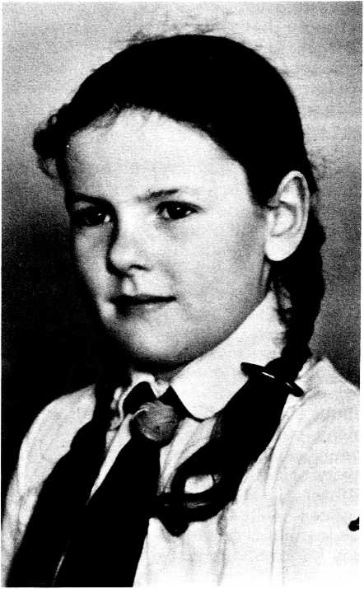

The author as a child at 10 in the costume of the Hitler Youth. Every child from 10 years on had to wear this uniform.

come this deeply rooted distrust toward people, which was so necessary at that time for safety’s sake. We learned to give answers which gave no information. Yet it is important in normal life to be able to trust and have confidence in other peo­ple, if we are to build any human relation­ships at all.

Through this teacher’s denunciation, several Jews and half-Jews of our peace­ful little town were either persecuted or just disappeared forever. The Jews were not allowed to walk on the pavement and had to attach to all their clothes the star of Bethlehem—the sign of a Jew. They were ridiculed, maltreated, insulted, and put into camps. 1 remember a fine Jewish girl, Rose, who went to our school during the first years: nobody played with her or spoke to her in or outside school. My parents encouraged us to invite her to become our friend. Rose used to stand alone leaning against the grey wall of the school yard during break time and stare sadly at the ground. "Rose, won’t you come and play with us?” "May I? Do you really want me?” You should have seen her astonished eyes that somebody did not despise her, even wanted her. How gladly she joined us! She was intelligent and musical and we sometimes played the flute together. Rose had an older brother who fought in the war and was very courageous. When he lost his leg in a battle, the Nazis declared him “Arian”! Obviously all his Jewish blood had been in that one leg!

The wife of the drug store owner, Nikotovski, was a Jew. This family was completely isolated: hardly anybody

entered the drug store or talked to the couple for fear of the Nazis. Father always bought his medicaments there and visited these dear people. In return, the Nikotovskis helped us some years afterward with valuable medicaments when we tried to help the sick refugees from the East on their endless treks.

We had many visitors in our home — people in desperation and burdened with fear or guilt. Often we children did not even know who they were—it was too dangerous to know. Some were Jews in hiding. Some were Nazis for whom the enormous burden of guilt and wrongdoing had become too much to bear. One such—a lady in a very high position—came to confess and get rid of her load of sin. Her task had been to inform upon and denounce the high Ger­man nobility and big landowners in Eastern Germany. She herself belonged to that class so her peers—most of the nobility were against Hitler—trusted her. ‘‘I cannot sleep,” she confessed, ‘‘my bad conscience follows me everywhere. They trusted me as a friend and I have betrayed them. I am going insane. Can I ever be forgiven? 1 come from a Christian home, I knew it was wrong. My guilt is constantly before me. Will God ever forgive me?” Mother and Father talked to her until she found God’s forgiveness and peace. They also helped her escape into hiding.

Many who came to us, especially toward the end of the war, were refugees without home or means, often separated from their families whose whereabouts they did not know. Our house often resembled a transit camp. Everybody looked for help, for comfort, for advice, for love, a meal, a bed, a couch, a warm place in the cold weather, or just for a roof. A Lutheran parson from one of the neighboring towns rang the bell a few days before we ourselves had to flee from the Russians. He wore his clerical garb and had in his briefcase only a prayer book and the Bible. We could scarcely believe him when he told us his story. “Yesterday 1 was called to hold a funeral service. A farmer fetched me with his horse and buggy. When the funeral was over we heard shooting just in front of the village. The village people were so afraid that they refused to drive me back home. So I started to walk home. After an hour or so, suddenly I saw two huge tanks ap­proaching me. I put up my hands and waited. The tanks stopped. A Russian of­ficer and some soldiers addressed me. 1 pointed to my clerical garb and to the golden cross on my Bible and tried to ex­plain that I had come from a funeral. 1 in­troduced myself with the word ‘Pope.’ The officer apparently understood some German. He put my hands down and talked to me in broken German: 'Pope, Vaterchen, nix Arm hoch, nur Soldaten Arm hoch’ [A clerical need not put his hands up, only soldiers]. Then he pointed out to me that 1 could not go back to my home town, Naugard, because there was too much fighting. 1 could see fire and smoke discoloring the sky in that direc­tion. The Russians showed me the only open road into territory still held by the Germans. Every other area was already taken by the Russian army.’’ He spent the night in a village and appeared at our door the next midday. His main concern was, of course, his wife and family. Were they still in the burning, fighting town or had they fled? We could not give him an answer.

One day father received what seem to him a remarkable letter through the post. Usually people in need did not write let­ters like this one because it was far too dangerous to write your secrets down in a letter. Letters were regularly opened and censored. In this letter somebody com-

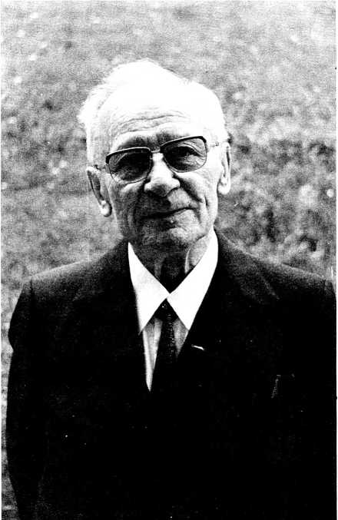

My father, Wilhelm Gottwaldt, aged 80.

plained widely of the terror of the Mazis and somehow laid out a plan to get rid of them. My father immediately felt suspi­cious. This letter was not genuine. It must be a planted, fake letter. He prayed about it with mother and both became con­vinced by an inward intuition that they should do something about it immediate­ly. So father took the letter the same day and gave it to the police. He had hardly left the house when an agent of the secret police demanded entrance to search his office. If he had found that letter, they would have arrested father. They wanted to have a reason for arresting him, for it was known that he did not agree with Hitler’s policies. Father was so loved by the people of the town that the secret police could never have arrested him without giving a reason. Therefore his enemies had planted this fake letter in our house. But God had warned him clearly so that he had escaped the snares of the enemy. Never in his life, except on this occasion, had he taken a letter to the police—it would never have occurred to him.

Chapter 5

War Service in the East

During the first years of World War II Hitler and his army were victorious everywhere. What would have been the result if he had conquered all Europe or even the whole world (which was his ultimate goal)? One can read it in his Mein Kampf and extrapolate further. Woe to everybody who did not keep to the par­ty line 100%, woe to committed Chris­tians, to Jews, to other races, except the Nordic race. So it was a blessing in disguise that the war was lost. When Hitler started to lose the war, everything was done in an attempt to save the situa­tion. Boys down to 16 years and men up to the age of 60 were called up for military service. Even women had to enter the army for certain tasks. 1 was 15 years old and in the middle of my high

school life when one afternoon we found in our mail box a startling notice from the state officials. In this notice, our household help, my younger sister, Christiane, and myself were ordered to appear next morning at the station, com­plete with clothes for three weeks and food provisions for several days. “Anybody not turning up will be pun­ished!” What did that order mean? Where did they want to send us and what for? There was not a clue. It was obvious: everybody had to obey this order. After having recovered from the initial shock, my parents tried in vain to find out what this was all about. Father hurried from one office to the other, from one official to the next, to free us from this doubtful obligation—but in vain. Orders are orders.

Next morning our parents accom­panied us to the station. A big crowd of girls, women, boys, and also some old men had already gathered—all as unin­formed as we. People from 14-55 years old had been called up. My sister was the 14 ... I was 15. A considerable number of older women and men were in a delicate state of health. All of us were loaded into long trains and transported eastward.

After hours of traveling, the train stopped at last. The huge crowd was divided into various groups and put in camps far from one another. To our great joy Christiane and I could stay together in a camp with 200-300 girls. We were put on a large farm near a settlement of mainly Polish workmen and their families. We 200-300 girls were bedded down above the stables and cow sheds in two hay lofts into which there was access by two fragile ladders. The whole loft was very flimsily constructed—only for hay and not for 200 girls. So it happened that occasionally when a girl walked a little heavily, the floor boards gave way, made even more interesting by the big bull directly underneath us. We tried to ar­range our “hay bed” on top of the very thin and light concrete floor as nicely as possible. Soon we were told by the female officer that the purpose of our transportation to the east was to dig in­fantry and tank trenches, as well as gun emplacements. We were to dig eight hours a day except every second Sunday. Over and above this we had to put in a set number of hours of drill per week. The sanitary arrangements were extremely primitive; they consisted of a long ladder laid across an open ditch in the open field. A 17-year-old Red Cross assistant nurse cared for the 200-300 girls’ medical needs. For washing for all of us there was a single primitive water pump in the stable. Later on, they added a water-filled liquid manure container on wheels from which the water flowed into a long trough in which the girls could wash.

We lived in this camp in the east from August to October, when it started to be quite cold. During the night we put more clothes on than during the day. An epidemic of lice and scabies broke out, as was to be expected under these cir­cumstances. The mail was strictly cen­sored and we were not permitted to give our parents or anybody our whereabouts or our address, or to write about the real situation we were in. 1 remember one day, 1 had just returned from work to my hay nest, when a number of girls started shouting, then weeping and sobbing. Quickly 1 went to the opening of our hay loft and observed a crowd of girls who were fighting downstairs on the court­yard. “What is the matter?’’ I asked. One of the girls answered: “One girl wrote a letter home that she was hungry and asked her mother to send her some food. Her letter was opened and read. Now she is being punished for spreading false rumors.” Later 1 heard from the girl con­cerned that they had broken her glasses, beaten her cruelly, and torn her blouse to shreds.

We carried out our work with spade, shovel, and pick. The tank trenches had to be dug 4m. (13 feet) deep and 4.5m. (143/4 feet)wide. Most of the girls were not used to this kind of hard labor. They were, like my sister and I, schoolgirls who came from sheltered homes.

One night—it was during the first days of our service in the east—an acute epidemic broke out. From all corners of the dark hay loft groanings and com­plainings could be heard, most of the 200-300 girls were writhing in pain. A number of them even fainted. Several suffered from fits of hysteria. It was in­deed dangerous, when all of the 200 and more girls crowded down the two narrow ladders which had no banisters, in order to get some fresh air. In the middle of the night all over the cobblestoned farmyard the sick girls lay in their agony, partly underneath the horse carriages. Halfway down the ladder, 1 too fainted and fell down into the void underneath—for­tunately into the arms of a soldier who apparently had come to a secret rendez­vous with some girl of the camp. The in­teraction between both sexes was, of course, very active.

Although we had been told our stay to dig trenches behind the frontier was to last only about three weeks, we were from time to time informed that we had volunteered our services to our country for some more weeks. This “free-will of­fering” was always made known to us afterward and in reality, of course, we were never asked about it.

Several times the trench area was at­tacked by bombers or low flying air­planes, but we were always mercifully spared.

At the time of our war service, Chris- tiane and 1 had not yet fully committed ourselves to Christ. Nevertheless, it was a real need for us, right in the midst of this awful atmosphere, to repair as often as possible to a solitary haystack to read together God’s word and to pray. There we really learned to appreciate our happy Christian home and the fellowship around the Bible.

At home father lay seriously ill with cardiac failure and several times he was near death. It was a very hard time for mother because she had to be prepared for the loss of my father or of us at any time. How happy and thankful we all were when, after months of uncertainty, we were at last reunited at home.

But this happy state of home life did not last very long. The Russian front ap­proached rapidly into East Germany. The idea of our having to flee had never struck us. Even if the Russians should happen to advance as far as our home town, we were determined to stay put to serve the church, the sick, the old, and the wounded. Never did we imagine that the town could ever be evacuated by force. We had observed and experienced the terrible misery of the refugees from further east, in the severe winter trekking in their horse carts through our town con­tinuously day and night without interrup­tion for months and months: old people, women, children, and sick, with as much clothing, food, and smaller belongings as the horse and wagon would carry. There were hardly any men in this endless col­umn. The men, of course, were all serving and fighting in the rear, so the women and the very old had to take over. All along the roads one could see stranded or broken carts with the contents strewn all over the ground, dead horses, crying children who had lost their parents. From time to time Russian low-flying airplanes strafed the roads jammed by fleeing peo­ple. In our little town the primary school was turned into a huge transit refugee camp. For a time father and we three daughters went there daily to look after those who most needed help as best we could. Our good drug store pro­prietor—whose wife was a Jewess— helped us greatly with medicaments, ointments, and bandages. My mother cooked soup for the sick who suffered from diarrhea, stomach, and intestinal

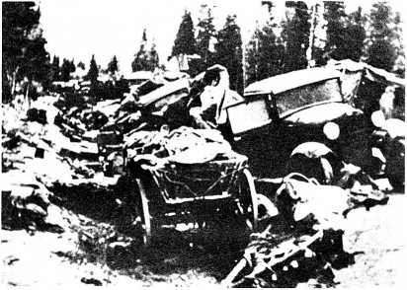

A typical scene in the latter days of the war: a road crowded with military and refugee traffic after a strafing run.

By courtesy and kind permission of Heinz Ebert

diseases. Of course, food was severely ra­tioned during these years and very scarce, so we had to act and help in faith, but the Lord never let us down. We never went without a meal ourselves.

No scheduled trains ran any more because the normal railway service had come to a standstill. All the same, refugees from the East German towns be­ing transported by special trains passed through our station day and night. Sometimes they had to wait for hours on railway sidings because the train lines were so jammed with military traffic. The young people of the town were organized to look after those refugees—to give them some food and generally be helpful. I will never forget the old, lonely, little silent lady who apparently did not feel well. She did not complain—there were so many who were complaining and needed help with changing the babies’ diapers, with food, etc. She sat silently on her old, small suitcase, while waiting for the new train into which the whole crowd of refugees had to transfer. I saw her sit­ting there, pale and weak and bent over. Some mother with her children wanted help from me. When 1 came back, the old lady was already dead—still sitting on her suitcase—nobody had noticed her last moments.

During those turbulent times a young Christian—a soldier who was stationed in our town—visited my father’s church services. We invited him to our home every time he had some hours’ leave. His wife and his parents lived in Western Ger­many in the Luneburger Heide. He had no relatives in eastern Germany and felt quite lonely in the army because he had found no Christians among his com­rades. So he was happy to get some Christian fellowship in our family. We used to talk with him about the political situation in Germany and the war with all its terrors. One day he told us, “If ever you should have to flee from your home, go to my parents-in-law who own a farm in the Luneburger Heide; they will help you.” As we had made up our minds not to flee before the Russians, we did not consider his kind offer very seriously. We had no relatives in the west—they all lived in eastern Germany.

Our home in Pommerania was beauti­ful and very spacious, and we possessed everything we could wish for. Naturally we enjoyed these worldly goods. Our whole family loved classical music and everyone played several instruments. If possible, we tried to come together on Saturday evenings for musical perfor­mances. These musical evenings were the highlights of the week. My father is an excellent pianist and imparted the love of good music into our hearts from early childhood on. A musical evening treated certain musical topics: one evening it was sonatas, another time evening songs or waltzes or fugues. When we were smaller, father would sometimes give us a piece of paper and a pencil—and then play. Our task was to guess the period when the composition was written and also the composer. With examples he showed us the characteristics of the various musical periods and the different styles of the composers, so that we learned early to distinguish them from one another: Bach from Handel, Mozart from Beethoven, etc. My parents often invited artists, poets, scientists, and other interesting people to our home, thus widening our horizons immensely. We often sang together in our family choir—the beautiful old German folk songs, classical vocal music, and hymns.

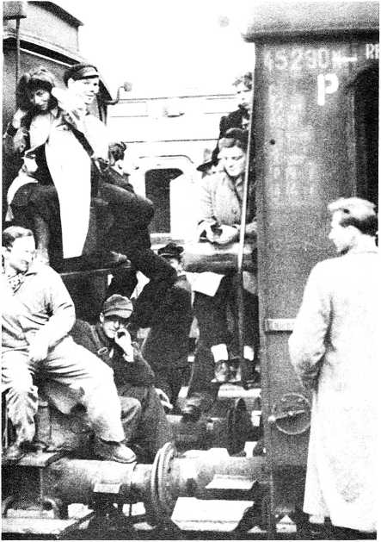

Typical scene at a German railway station after the war.

By courtesy and kind permission of Heinz Ebert.

Chapter 6

Flight Before The Russians

In the middle of the night of March 4/5, 1945, all the sirens in our town suddenly started wailing. At the same time, we could hear loud cannons shooting and machine guns firing. Immediately we all jumped out of our beds, put some clothes on and ran out into the streets to learn the latest news. Everywhere we observed nervous people hastening around, carry­ing suitcases, and drawing hand wagons behind themselves. Children were crying, men and women quarrelling, exhausted soldiers slinking about, and endless rows of badly guarded prisoners of war marched through the dark city. “Didn’t you hear the sirens? It was the signal for everybody to flee. The Russians are at the city gates, hurry! Everybody hurry!” a soldier shouted. But we did not really

want to flee. Crowds of people with fully loaded hand wagons and baggage left the town, others returned back home discouraged because all the roads were blocked with soldiers, refugees, dead horses, broken down buggies, and flee­ing army trucks. Only a single bridge in the whole surroundings across the Oder, the big river, was still usable for escape— all'other bridges were either occupied by the Russians or blown up. And this one and only escape bridge was hopelessly crowded. Everything was chaotic and people were possessed by panic and despair. One gentleman, totally confused and out of his wits, ran through the streets with two hats on his head, a violin stuck under his arm, grasping a small briefcase in the other hand—he had nothing else with him, not even a coat at this cold season. During that day the order was given that every single civilian had to leave the town. The town was to be defended and was to become a huge bat­tlefield. Now everybody left on foot. All the 13,000 inhabitants streamed out of the town and mixed with the flood of refugees from the surrounding area on foot or by cart, the retreating SS trucks and hundreds of foot soldiers moving in both directions. A number of handi­capped old people and the sick were transported by the retreating SS trucks.

Most of the SS soldiers fled in cars, while old, ordinary soldiers and young boys of 16 and a littler older had to take up the battle positions for fighting the already hopelessly lost war. Around midday the town was almost empty of all inhabitants. We realized there was no longer a reason for us to stay—father’s whole parish had left—so every member of our family— father, mother, Martha (our dear house­keeper), Rosemarie, Christiane, and myself—everyone grabbed one or two suitcases and buckled on his rucksack and off we marched. How grateful we are to God that he allowed us to escape from the Russians then. We later learned peo­ple from other areas who were overtaken by the Russian army went through hell—physically and psychologically.

After we had marched a few miles—we advanced very slowly because of the overcrowded, blocked roads and the con­stant attacks by low-flying aircraft—on our request a retreating SS truck took us aboard. On board this truck something horrible happened. During our various conversations with some people from our church who had joined us, the SS soldiers somehow got to know that my father was a cleric. One SS soldier, who was slightly drunk, tried to threaten father—"I’ll catch him in this crowd, even if he jumps down from this truck to escape!”—etc. But father did not react and kept quiet all the time. After a while, the same SS man drew his machine pistol and played sadistically with it to frighten us. Sudden­ly he jumped up and aimed his weapon at father, although there were quite a number of other people in the car. We threw ourselves between my father and the half-drunk soldier, while praying fervently to God for help and deliverance. At this very moment some low-flying Russian airplanes came diving down at us and started to attack the whole crowd with their machine guns. The Russians knew this was the only road which the military and the refugees could still use, so they tried to stop the retreat with at­tacks from the air. All trucks—in fact all traffic—stopped moving and kept as quiet and motionless as possible. The hundreds of refugees and infantrymen quickly hid behind trees or bushes. We could use this unexpected, yet so prac­tical and prompt help to call some or­dinary soldiers for help. They snatched the dangerous weapon out of the SS soldier’s hand and transported him into the truck driver's cabin. This sudden at­tack from the air had obviously been an act of God in answer to our prayers to save father’s life.

Some time later, the truck stopped in a small village, a rendezvous point for the

retreating military troops. We had to get out. Only a few miles further was a town. “Why had the truck journey not ended there in the next town where further transport would surely have been easier? Why get stuck in this little village? Would the Russians now overtake us here?" we asked ourselves. There were no more trains running. We were rather discour­aged. Only father comforted us: “Surely God knows why he led us here into this village. Let us trust in Him.” We learned that this little place had a small railway station. We spent the night at the local pastor’s home—a perfect stranger. The next morning—even though we knew there were no more trains running—we walked to the station to see if perhaps we could catch a train! Lo and behold! At the very moment our family arrived there, an overloaded goods train with valuable machinery—the very last one—entered the station. The goods train drew a single passenger carriage, which we boarded. Our family was the only passenger, a miracle in those times of overcrowded refugee trains. The train's route, which we learned from the accompanying rail­way official, ran for a short time in the same direction we wanted to go. As we had no other place to go, we headed for the home of the Christian soldier who had so often visited in our home. Now something really miraculous happened. When the train entered the town where we should have left it, we heard the con­ductor shout: “The itinerary of the train has been changed,” and named the des­tination. “That’s a bit further in our direc­tion!” we realized with satisfaction, and stayed on. And again, when after an hour or so we reached the town where we should have changed, the train’s itinerary was suddenly altered. The same thing happened several times, so we were able to stay further and further in the same train without paying any fares for the route. There were no more conductors, tickets, or fares to be paid. Everything was in dissolution.

Finally, at the destination of the goods train, we got out. How to get further was the next question. We were still quite a long distance from our soldier friend’s home village. There were hardly any trains running in those chaotic times, even far behind the combat area, with the exception of very few military or crowded refugee trains. These traveled very slow­ly, sometimes for months because they were so often shunted onto sidings. While taking counsel on what to do, a ful­ly loaded military train rolled into the sta­tion. A crowd of soldiers got out of the cattle cars. The conductor shouted: “The train is now heading for Schwerin!” ‘‘That’s exactly our direction!” Quickly we mounted the vacated cattle car and finally arrived, after a long time, in Soltau, a town of the Luneburger Heide, not far from our destination. Nearly at the end of this perilous journey, we had another unpleasant experience. During the night at the station, my two suitcases were stolen—most of my preciously saved belongings—yet it was so much more important that we were all together and not separated like so many other families.

Between this small town, Soltau, and our destination, there ran (in peace time) a narrow gauge railway which long since had ceased to function because of the constant attacks of low-flying airplanes. But we had experienced so many mira­cles on our flight that we courageously marched to the small station. Again, lo and behold! When we arrived there, a single mail car with a small locomotive in front was waiting there, ready to start off! It was running for the first time for weeks and probably for the last time, too, before the end of the war. We entered the train and arrived safely in the romantic village, all surrounded by heather and beautiful forests: Neuenkirchen, the home of our Christian soldier friend . . . only three days on the road as refugees, while most of the other refugees had experienced weeks, often months of utmost hardship, endless difficulties, of separation, of bombing, of sickness, of being unwanted everywhere, of hunger and thirst, of ex­treme cold! We had not deserved this kindness. I cannot tell you how grateful we were for the good hand of God upon us. But we learned afterward from Chris­tian refugees who had been on the road for long times and had been tested much harder than we, that God had also wrought many miracles for them and per­mitted them to aid and comfort other refugees. We still cannot comprehend why God in His goodness had only burdened us with such a short, com­paratively easy test.

Having left the train, we stood ponder­ing at the desolate station, which was partly bombed. “How should we proceed now?" mother asked. We did not know the people we were going to ask to take us into their house. And they did not know us either. How could we, strangers —a family of six—impose ourselves on this unknown farming family? Maybe their house was already crowded with refugees; after all, the whole area was flooded with homeless people. Every house and family in western Germany had to take in refugees from the east. Because there was not enough room for all the refugees, schools, church rooms, and community halls had been converted into mass refugee camps by putting camp beds or straw into them. We all, especially mother, felt very embarrassed and shy and we consulted with one another at the station how to approach the project. At last father and my youngest sister took courage and started out to find our soldier friend’s people. The rest of the family stayed at the sta­tion. The appearance of six people all at once would have been too overwhelming for the farmer! When daddy and my youngest sister had found the old straw- thatched, half-timbered farmhouse and approached it, the huge wooden door opened and an elderly, kind farmer walked straight toward them, stretched out his hand to greet them, and inquired: “Are you Pastor Gottwaldt?” Astonished, father answered in the affirmative. “But how could you know me? We never met before!” “That’s right,” he said, “but my daughter [the wife of the soldier who had often been to our home in Pommerania] had a strange dream last night. She dreamed that you and your family had to flee from your home and were asking us for shelter. So Frieda prepared her small apartment for you. Everything is ready. Welcome here! My daughter and her baby son have moved to our farm." My father and Christiane could hardly believe their ears and eyes. In such a special way God had prepared everything for us. Usually we do not place much im­portance on dreams, but obviously this special dream was God-sent and we were extremely grateful for it. It was the answer to my mother’s continuous prayer during our flight to prepare the farmer’s family for our arrival.

In this nice little apartment we stayed until the invasion by the British army, which confiscated it and used it for their officers. We had to move into an old church hall, out of use and partly bombed, where we camped very primi­tively for a whole year. We constructed our various “rooms” from old school maps, which we found rolled up in a cor­ner under some debris. We had thus divided up the big hall into smaller rooms: 3 bedrooms, living room, and kitchen. You must remember, in those times you could not buy anything in the shops except the strictly rationed food. Germany had completely collapsed. As there were no beds, we found some rusty bedsteads with straw sacks in an empty, dilapidated prisoner of war camp. But I am sorry to say we were not the only in­habitants of this lodging: all that creeps and crawls lived together with us under the roof. By means of insect powder, rat poison, constant house cleaning, and en­durance, we finally conquered the hall for ourselves. For a long time our bodies showed the wounds and marks of that ob­noxious battle!

To our great delight, mother found— besides other useful things—an old piano hidden under the wreckage of the bombed part of this building. We all set to work excavating this precious find, with the hope that the damage would not be too serious to use it. First of all, we cleaned it inside and outside. It needed a lot of repair—many of the strings were broken and some of the keys were damaged. My mother was not only a good organist, but also an excellent mechanic and instrument builder. So, by talent, diligence, and know-how, she repaired and renovated this old war in­valid into a piano which we used for a long time. As our “living room” was unusually big for those times of cramped quarters, my parents started to organize special evenings for some of the refugees, to help them get over these dif­ficult times. Many of them had possessed huge farms in the east—eastern Germany was the country of the big landowners— and here they sat impoverished, often despised and in despair, cramped closely together in a small room, living together with people with such different habits and surroundings. They would have to start their lives anew, which was not easy for the older big farmers and landowners. It was also difficult for the West Germans to share their houses with strange people and to live so close together with them. Sometimes the eastern farmers, who were used to a free life style, turned out to be rather difficult, self-willed neigh­bors.

in these times of severe rationing and lack of food, the refugees had to pawn their rescued jewelry—even sometimes their wedding rings—to extract some ex­tra food from the local western farmers. There was a story told—if true or not, I do not know—that a refugee complained to the parson of a village that a farmer had demanded his wedding ring for payment of some food. The parson was disgusted. Next Sunday he vehemently preached from the pulpit that it was misuse of the poor and not pleasing to God to extract somebody’s wedding ring from hungry people in payment for food. He implored the farmer, without mentioning the name, to return the golden ring. The ser­mon hit home! After the service five or six wedding rings were secretly and silently handed over for return to the par­son. But there were also a great number of local families who were fine people, helping the refugees unselfishly where they could, and trying to understand and make friends with them. So you see there was a lot of tension and quarrelling going on between the refugees and the villagers —each one not understanding the other’s situation. Father listened to complaints from both sides and tried to mediate as best he could. We all prayed for solutions and help. First of all he put a big wooden sign up on the market place with the words: “Bear ye one another’s burdens and so fulfill the law of Christ” (Gal. 6:2). Then he tried to visit every family in the village to listen to their problems and help them. They soon loved and trusted him. And thirdly, my parents organized evenings in our simple church hall home and invited as many people as possible from both sides to get into better contact. Depending on the topic of the evening, we invited different people: once we in­vited a refugee tenor singer and father ac­companied him on the repaired piano. Another time, a veterinary surgeon from the east gave a very humourous lecture on “Animals as patients.” Then a talented carver and artist, just recovered from some months of tuberculosis, talked about the art of carving and showed a number of his beautiful art pieces. One evening, we three girls, accompanied by father on the piano, gave a folklore even­ing by candlelight with old German folk songs. Many of the visitors who attended would not enter a church, and yet their hearts opened up in these evenings which father always closed with a Bible verse and some personal words. Some of them became Christians and good friends of ours.

Not long after our arrival in Neuenkir- chen, the Western Allied Forces ap­proached nearer from day to day. The Americans, the English, the Canadians, the French, and the Belgians invaded and conquered West Germany rapidly. The war was hopelessly lost and a real front line did not e/ist any more, yet Hitler and his friends decided to fight until the last man. Everybody had to believe in the "Endsieg” (end victory). Soldiers separated from their regiments by the terrible happenings of the war—they were often the only survivors of a fighting group, or they had been cut off—tried to get home or find other groups. They often got lost in the words and were desperate and worn out. The Waffen SS and the Nazis had formed special execu­tion squads to look for these single and lost soldiers. If they met men or soldiers behind the front who in any way looked suspicious to them, they were executed as traitors and hanged on trees as a public warning. Yet everybody was tired of the purposeless and nonsensical fighting and killing. Why not end the war

and stop more killing and misery?

One day the shooting of cannons and machine guns started in the close prox­imity—only a few miles away. During the whole of the following night, retreating troop remnants passed our village. Many of them were Slavs who did not even speak any German. They had been fetched from Russia and Poland and other eastern countries during the war and forced to fight for the Germans (later they were killed by their own Russian leaders for treason when returning home to their countries). At the same time, American and British bombers and low- flying airplanes flew over the area and at­tacked several times. Because of the con­stant danger, one night our family left the village and took shelter in the nearby woods. It was a restless night, as no one was sure if we would live to the next morning. We were in danger from above and all around us, but we were protected. The next morning everything became very quiet and empty—no more receding troops, no more shooting (except in the very far distance)—and yet the atmos­phere was laden with silent tension and an awareness of some near event.

If the Allied Troops only marched in now, there would be no fighting and no killing on either side! After two or three very peaceful days, a tired, depressed group of German soldiers with a sinister- looking officer entered Meuenkirchen. The villagers very willingly showed them the quickest and safest way to retreat, but the officer became very angry and shouted at them: "We have come here to defend the place and to fight till the last man. There is no question of retreat." He ordered the soldiers to dig manholes and to prepare everything for the battle. Mow the women of the village were struck by an excellent idea. They saw the ex­hausted, depressed, hungry faces of the soldiers, and they knew how hopeless and in vain further fighting and killing would be, so they invited them for a hot meal and started very slowly to cook a good dinner for the soldiers, who had not had a warm meal for days and weeks. They sacrificed the food from their own rations and prepared everything with love, some of them thinking of their own husbands and sons who were also sol­diers at some unknown place far away.

They hoped that the English troops might meanwhile march into the village without resistance. But they were wrong. The soldiers had not quite finished their delicious meal when the order came: "Every man to his fighting position!” The sad, tense expressions on the faces of the battled-tired soldiers touched our hearts. After a short time, the shooting at the end of our village started. All the in­habitants of the house fled down into the cellar. The crack English troops, “the Desert Rats” which had fought efficiently against Rommel in the North African desert, conquered the village in half an hour with their superb tanks. The tanks entered the village so quietly that we only noticed them when 1 peeped out of the small cellar window and saw them stand­ing in front of the house with the cannon barrel pointed directly at us. 1 had secret­ly prepared a white flag. But there was no time to put it out of the window, because at that moment the door of the cellar was torn open and a menacing-looking ma­chine gun was aimed at us. A huge Eng­lish soldier in his khaki uniform held it in his hand, silently mustering us all. My eldest sister addressed him: “We are only civilians.” He and another soldier, also with a machine gun, searched the whole house. When they found no soldiers and no resistance, they talked to us kindly and let us come out of the cellar. “You are not allowed to leave the house for several days or to go nearer the windows than two yards. People who disobey will be shot.” They were correct and kind and warned us to hide our watches and jewelry before the following troops ar­rived, among whom were some undesirable elements—especially the

French Canadians and Poles.

Only a little later, we recognized through the window a number of the Ger­man soldiers whom the women of the vil­lage had fed before they left to defend the village. They were now prisoners of war, but were quite happy—the war was over for them. The English did not treat them badly, but they had to face a long and very hard captivity in open air camps, together with tens of thousands of other prisoners of war. Many of them died of starvation, cold, and disease—food then being scarce in many European coun­tries.

One soldier and a civilian were killed during the fighting. An English officer asked father to put on his clerical garb— he was allowed to leave the house if dressed and recognized as a Lutheran clergyman—and bury the two corpses. He also visited one wounded civilian. During the first days of occupation, no shops were open and no Germans were allowed on the streets. As food had been scarce for a long time, we soon ran out of provisions. Every day we saw the English front-line troops receiving new canned food rations: meat, fish, vegetables,

biscuits, butter, cheese, jam, and milk powder. When they were given the fresh supplies, the soldiers usually put the un­used old ones on the street or somewhere outside and destroyed them by driving their tanks over them. But some of the kinder Englishmen put them on a special place near the road and left them there untouched and fully sealed, because they did not want to destroy the valuable food and knew the Germans were hungry. We saw a whole pile of cans lying not far from our house. But what was to be done? We were not allowed out of the house. Martha, our housekeeper who was like a member of the family (and very courageous), had a good idea. She waved to an English military sentry with his loaded machine gun and told him to ac­company her with his pistol as a guard to the pile of food cans which she wanted to fetch. He was kind and marched faithfully protecting her from behind while she gathered all the precious supplies. How thankful we were for all the good things, many of them we had not seen for years! How the Lord provided for us! When she entered the house with her arms full of the rare delicacies we had a real feast although these victuals had to keep the wolf from the door for quite some time and we rationed them strictly.

During one of the first occupation days, father was visited by a British col­onel, the commander of the area, fol­lowed by a sentry. At first we were shocked. What were these men going to do to father? All three of them had left the house and driven away in a military car. In fear and trembling we waited for further news. After one hour, they brought father back. He told us that the colonel had wanted to put a new mayor into office. “The old Nazi mayor barri­caded himself in his house, full of fear and bad conscience before the English. They took him into custody preliminary to his trial. The colonel made investiga­tions and thought that I was the person to help him find a good reliable new mayor. So we visited the gentleman 1 suggested as new mayor for a first contact.”

Post

World War II

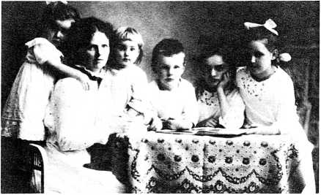

My widowed grandmother with her 5 children.

Chapter 7

Grandmother And the Russian Occupation

There was still the great anxiety of the fate of our relatives in the east, of whom we knew nothing. Were they still alive? Would we ever see them again? Had they been killed or died like many refugees on their way to the west?

Even today, if one goes through Ger­man post offices or police stations, one can still find—after nearly 40 years— photographs of middle-aged men and women with the caption: “Who am I?” These are mostly people who lost all their relatives and friends during the refugee treks or bombing attacks when they were

small children and now wish to have their identity and names and age established by family resemblances. They usually give some distinguishing features to help this process.

The time was just before the end of the war in Silesia, the southeastern part of Germany which now belongs to Poland. There my grandmother, Else Urban, owned a beautiful big 16-room country house with a large garden and park around it, in the midst of the beautiful mountain range called “Eulengebirge.” We had sometimes spent very happy holidays there, together with our relatives. My grandmother was a very remarkable personality. She had early become a widow, shortly before her fifth child was born, and had an open house for everybody. In addition, she was very active in Christian work among women and helped hundreds of people with their problems, because she herself had ex­perienced God’s help from day to day in very difficult times. She told us God had given her a wonderful task in life: the task of consolation.

Grandmother appeared to be a very happy person. Everybody noticed it. Once, when she was over 70, I entered a pharmacy with her to buy some medica­ments because she had cardiac disease and was also diabetic. The pharmacist, an elderly lady who looked very bitter and disappointed, served us and suddenly remarked: “My dear lady, how can you look so happy at your age? Life for you is nearly over, there is nothing more to ex­pect. Although 1 possess everything in worldly goods 1 can wish for, 1 feel so disappointed and frustrated.” Grand­mother told her how happy she was as one who experiences God’s love, forgive­ness, and care every single day, and how exciting and adventurous it was to follow Christ and His word. And then she told her about her own life as a widow with five children to raise and educate, about the difficult times of inflation, etc., how God had provided every need, and even more. The unhappy-self-centered lady in­vited her into her house and after several visits, became a different person herself by accepting the good news of the Bible.

Now during the very last days of the war, grandmother’s house was crowded with 40 people, refugees and other home­less persons, as well as two of her daughters (Hilde and Dorothea) and one daughter-in-law with their children—their husbands were in the war—so most of the people in the house were young women, girls, and children . . . and grandmother. Grandmother used to tell us the following story: On the 8th of May, 1945, the day of armistice, the victorious Russians stormed over the mountains to occupy the whole eastern German territory. The constant stream of the overloaded refugee farm trucks with the lowing cows and whinnying horses and the misery of the homeless people had suddenly stopped. Then on the evening of May 8th everything became quiet. Only a few Poles rushed silently around the house. Later on they learned that the Poles had pointed out grandmother’s house to the Russians because of the many young women and girls in it. Suddenly at about 10 p.m., the first Russians drove into the village and stopped directly in front of the house. Other cars followed. The com­mand was given: “Get out of the car, en­circle the house. Take care that nobody leaves the house!” One of the young ladies knew some Russian and breath­lessly reported what she had heard. Terri­ble things would happen now. At that moment the Russians hammered at the front door, smashing the glass panes in it.

Grandmother courageously unlocked the door and about 17 strong men dashed up the staircase wildly looking around them. When they perceived all the young women around her they let out a long wolf whistle. “Ah!” The Russian- speaking lady tried to quieten them down. But my grandmother declared in all simplicity: “Gentlemen, we ladies and the children are without any protection, we put ourselves in your care." Some of the Russian officers understood German. But they had decided long before exactly what they wanted to do. So grandmother quickly sent the young people into their rooms and asked the Russians if she could prepare them a meal. They impa­tiently refused and searched through the whole house, through every single corner with the help of a huge dog. Soon the whole house was turned upside down and reduced to a complete chaos. They plundered. Many articles, especially clocks, watches, and valuables, disap­peared with them. But it was a miracle that they did not harm or touch a single woman as the Russians usually did every­where. Of course, all the women con­stantly prayed for God’s help and protec­tion. Grandmother gathered all the young women and children around her­self. When the tension grew unbearable the women started to sing the beautiful old German hymns and songs of the faith. They sang one song after the other—for about two hours. Their hearts became quieter and more confident. This was apparently something new to the brutal Russians, most of them officers. They restlessly came and went all the time and stared at the singing women.

But nobody touched them. Then sudden­ly the men signaled to my grandmother to follow them out into the kitchen. They wanted to separate her from the young people, somehow feeling that she possessed some spiritual strength which hindered them from doing what they wanted to do in this house. They ordered grandmother to prepare a meal: she had to fry all the eggs she had. They brought other food for her to fix and finally they gave her a very long smoked sausage and ordered her to cut it ever so thinly and bring it to their colonel downstairs. While they gave grandmother these orders, she noticed their wideset, deceitful eyes and instantaneously felt they wanted her isolated as long as possible from the young people. So she did the only thing possible in that situation. She looked the two Russians straight in the eyes and prayed loudly in front of them: “Lord

Jesus Christ, please prevent that which these wicked people are planning!” At that moment the Russians looked terri­fied, turned around, and fled out of the room. She carried the meal down to the colonel and afterward went back to the crowd of young women, girls, and chil­dren. Mot one of them was molested—it was a miracle! Hilde and Dorothea told her that after they had fetched her away into the kitchen, many Russians, one after the other, had come and tried to enter the room, but every time they had again left the room after a few steps as if blocked by an invisible power. They all had experienced that God had sent his angels to protect them from their enemies. They were full of thanks and praise. A little later in the night, two more Russians knocked at the door (can you imagine Russian soldiers knocking at the door of their prisoners?!) and asked for cigarettes. At 3:30 a.m. another officer ap­peared; he was tall, broad, and strong, and his chest was full of decorations and ribbons. His glances were devilishly un­pleasant. It seemed to them that again and again some Russian tried to find out why they could not get near the women as they had intended. This high officer stared at the scene protractedly and penetratingly. “Let us sing some more gospel songs,” grandmother suggested when the tension and fear increased. They sang—and he sat himself down on a chair in front of them. Finally, after one or two hours, he stood up from his chair, bowed to the ladies, and said politely, “Mow you can go to sleep safely—good­night." What a miracle! Unprotected women marvelously preserved in the middle of peril! God answered the pray­ers of His children, of those who trusted in Him. Mone of the 40 people in the

house was molested.

Downstairs the Russians had made themselves very much at home in grand­mother’s several big reception rooms. While my relatives and all their friends were miraculously protected in the first and second floor of the house where they all lived, the Russians had fetched a number of girls from the village, especial­ly those who were rather loose with men. Their Polish friends had pointed them out. With these girls from the village the Russian soldiers and officers spent a night of sexual orgy. They had gagged the girls with candle wax so that their cries were partly stifled. When the Rus­sians left the house hurriedly at 4:30 a.m., they left behind them a scene of total devastation and filth. The people upstairs had heard the wild and noisy go­ings on below, but had not realized the disgusting things being done there.

During this night of terror under the Russian soldiers, many of them Mongols, most of the villagers had fled from their homes into the surrounding woods. These refugees from the village, among whom were also Christians, had kept grandmother’s house under observation from their hiding places and suspected what was going on. They had noticed the violent crowds of Russians storming the house and moving around all the night

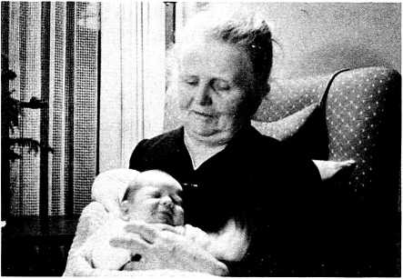

My grandmother Frau Pfarner Else Urban, at the age of 70 with our oldest son.

with diabolical restlessness. They had feared the worst. They therefore prayed the whole night for those Christian girls and young women in the house they were watching. But on returning to the village the next morning they were speechless on learning that none of the young women in grandmother’s care had been molested in the least.

A few months later the Russians left the area and the village was taken over by the Poles. The commander lived in two big rooms downstairs. This was a very bad and difficult time. The young Polish lieutenant was satanic. The Polish officer with his comrades used to drive on their motorbikes right through the entrance door of the house, through the corridor into the rooms downstairs. They put big containers full of petrol right inside the wooden floored entrance hall. Often the floor was soaked with petrol so that grandmother sometimes secretly stole downstairs to dry and clean the wet floors for fear of a fire or an explosion in the house. The Poles usually rode into the house smoking their cigarettes. Every night the noise of the drunken com­mander and his drunken girls could be heard in the whole neighborhood. They shot the neighbors’ pigs and any other domesticated animals, danced in heavy boots on tables and beds, and smashed furniture, crockery, and pictures on the wall. But it was miraculous: none of the scoundrels ever entered my grand­mother’s first or second floor. Neighbors watching these doings often remarked: “Why does God allow these things to hap­pen in the house of dedicated Chris­tians?” So grandmother answered them: “God allows it to test our faith. He has helped and protected us so far, so we will trust in Him. It is better that we have to endure this hardship than somebody else.”

One night the young Polish lieutenant planned a special immoral party down­stairs. Everything was prepared: food, lots of alcohol, and all kinds of musical and social amusements. Only the girls were still missing. So the young officer took his big car—he stole the cars he liked best regularly and openly—and rushed at high speed to the town to find a number of loose girls with whom to spend the night. It was a rainy night. His car skidded dashing around a corner, turned over while being thrown into the field, and his head was cut by the window glass and smashed against stones, so that he died immediately. His companion was unconscious. It was a terrible judg­ment. From that night on there was no more outrageous celebrating—it became quiet downstairs.

Food was very scarce at that time; even salt, flour, and bread were not to be had. When the women were too hungry, Aunt Hilde and Aunt Dorothea walked four hours over the mountains to a Christian farmer who helped them with a little milk, bread, and salt, although he himself had not much to spare. In the lonely mountains they were sometimes met by Poles or Russians who tried to molest them. But every time God saved them in the last minute from any danger.

A few weeks later, one morning grand­mother’s household was ordered to leave the village on ten minutes notice and was driven out of house and home by the

Poles. These homeless Germans were transported by the thousands to the west. They had to walk long distances between transports, saw the inside of cattle cars, and arrived weeks later in the west in 1946 in a very reduced state. How glad and grateful we were when we got the news just one year after our own flight from the east that our relatives were still alive and safe in West Germany.

Getting a Job

Until the local Lutheran pastor re­turned home to Neuenkirchen from the war—for some months he had been a prisoner of war in the hands of the Ameri­cans—my father acted as pastor in his place. But after that, of course, father was without a job and our family practically without any income. Each day this delicate situation was the object of our family prayers. Usually we had our Bible reading and time of family prayer after dinner. It was very difficult to find a job because there were so many refugees looking for jobs, as well as the men com­ing home from the war to their old jobs or looking for new ones. Everything was hopelessly overcrowded.

One day after dinner, father started to thank God for the church He had ready

for him and us. We all were surprised because none of us knew of any open position offered to my parents. So after the prayer Rosemarie asked father why he had thanked God for a position, even though none had yet been offered to us. “During our prayer 1 became convinced that God had a church ready for us and that He was going to show where very shortly. That is the reason for my prayer of thanks." We were very curious to see how and where God would give us a job and a home. A very few days later we received a letter from a fine church in Frankfurt to say that they were inviting father to be their pastor. We stayed at that church for 17 years.

Rosemarie, Christiane, and 1 had ex­perienced, together with our parents and Martha, the whole period of flight from the east to the west. There had been a number of difficult situations, and all the time we had unconsciously or conscious­ly observed our parents’ reactions and at­titudes. Of course, we had often com­pared their behavior to other refugees’ behavior. Father had never uttered a word of complaint; he had always en­couraged us and others. He tried to give mother and us as much pleasure as possi­ble. If other people felt sorry for my parents having lost house and posses­sions and having experienced so many hard things, both usually answered: "It was not easy but think what others often had to put up with! Cinder no circum­stances would we have liked to have missed these difficult and eventful times during the flight. They showed us how at every moment and in every detail God cares for those who trust in Him. We can rely on Him. These times have enriched us spiritually and have strengthened our faith.” Mother often declared: ‘‘From those days 1 have learned in a special way to be absolutely dependent on the Lord for everything, and He has never failed us.” And father remarked: “This was the only way to make us understand other people’s suffering and loss and to be able to help them.” As a family we had learned to appreciate much more all the positive things in life and to be much more thankful. We also realized it was not to be taken for granted to have a roof over your head, or to possess a bed into which you can slip when tired, or to have enough food to satisfy your hunger. How precious the most simple matters and utensils in the house became to us! (Eph. 5:25 and 27.) And life itself was the most valuable present! How many thousands had lost it during those last weeks and months!

Through all these experiences God had spoken very seriously and personally to my two sisters and me. Our parents and

Martha had a direct relationship to the Lord Jesus Christ, and throughout our ordeal they had lived accordingly. But one could not have said the same of us. From our childhood on we knew the good way through the upbringing of our parents, but we had not yet personally started it. The “general faith” had always been there, but the clear personal deci­sion to follow and obey Jesus Christ and His word and the assurance of His salva­tion was still lacking. We all had ex­perienced miraculous help and guidance during our flight. So one evening in a service we three girls decided whole­heartedly to follow Jesus, Who had sacrificed Himself for our salvation from sin, and we confessed it publicly. This was a very happy day for our whole family and marked the commencement of our Christian lives. It decided not only our personal lives, but also our partners in marriage later on. None of us would have considered the idea of marrying a non- Christian husband, no matter now nice he might have been from a human point of view. We had seen too many Christian girls taking non-Christian husbands with the resulting difficulties in marriage and family life. We learned that harmony in the psyche and spiritual matters was more important than purely sexual mat­ters.

Frankfurt

in Frankfurt/Main, father became the pastor of an evangelical church known as the “Nordost Gemeinde,” which had been totally bombed out during the war. Many of the church members were scattered; some of the families with children had been evacuated to the country because of the constant bombardments. Sometimes whole schools had been moved into the country because school routine had become impossible—the bombing had taken place day and night—and often the parents had to stay in town because of their jobs and obligations.

Frankfurt had been very badly de­stroyed: most of the schools and

churches, as well as ten thousand apart­ments, were razed or ruined. Blocks upon blocks of buildings were devastated and thousands of people had been killed or burned in the raids. Our church and the whole area around it was a scene of

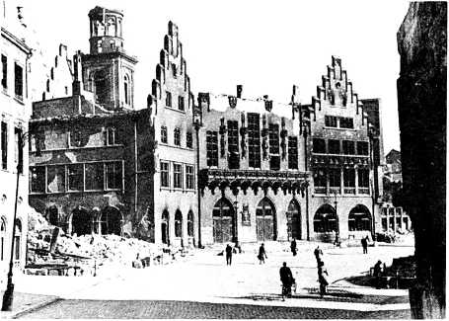

Bombed out Frankfurt city center shortly after the Sec­ond World War.

By courtesy and kind permission of Heinz Ebert

destruction. The vicarage was also gone. So the small remnant of Christians in that church gathered every Sunday in a room of an intact school.

Our family had to look around for an apartment in that hopelessly over­crowded city. Because accommodations in this bombarded city were so scarce, the town authorities strictly rationed liv­ing space to a minimum number of square yards per person so that most apartments had to take in additional peo­ple.

We were very happy that the church

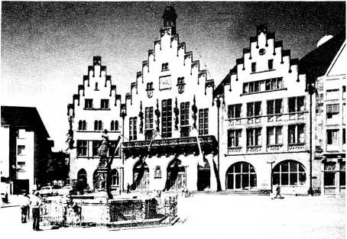

The rebuilt city center of Frankfurt today.

By courtesy and kind permission of Heinz Ebert

elders had found room for our family of five in a widow’s apartment—IV2 rooms with a kitchen and a bathroom, both of which we had to share with the owner. Our housekeeper had a small bedroom about a mile’s walk away.

When the schools had started afresh after the end of the war, my sister and I had continued high school life for several months in Neuenkirchen. We found a good high school in Frankfurt—but it too was partly bombed. At first it was hard to get back to school routine after all the ex­periences we had gone through. How­ever, soon we caught up and enjoyed the challenge of learning again. 1 also con­tinued my musical education on the violoncello and later on the organ.

After a few weeks we moved into a three-room apartment.

My parents took great pains to build up the church again. One of father’s first in­tentions was to rebuild a church from the ruins. But how could it be done? First, there were no finances. People were very poor: many of them had lost everything by bombing or by fleeing, and then the German mark (money) had been drasti-

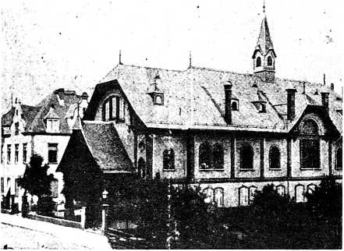

The old building of father's church in Frankfurt before the bombardment.

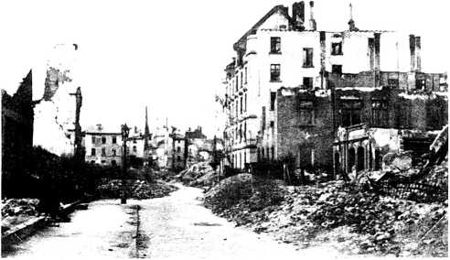

Another view of my father's bombed out church—on the right.

By kind permission of Heinz Ebert

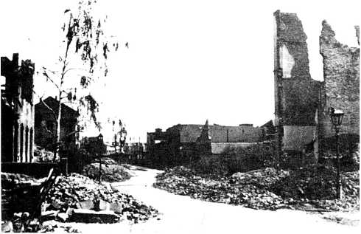

Frankfurt after a bombing raid. To the left is father's bombed out church.

By kind permission of Heinz Ebert

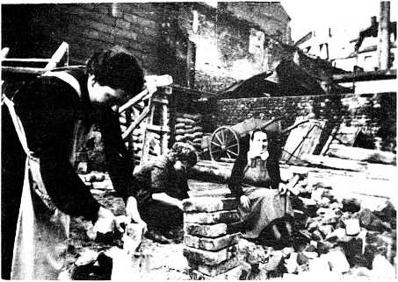

Cleaning the old bricks from our bombed church in Frankfurt to build the new building (1953).

cally devalued. Second, even if money had not been so scarce, there were no materials to be had. Germany was economically ruined.

So the Christians prayed for guidance in this matter. They came to the follow­ing conclusion: the members of the church would themselves rebuild a very simple church building from the ruins of the bombed old church. Everybody would sacrifice as many hours per week as possible for building labor. Women and children cleaned the mortar off of the old bricks. Then the men were to start a new building with the cleaned bricks. We

My father's church restored 1960.

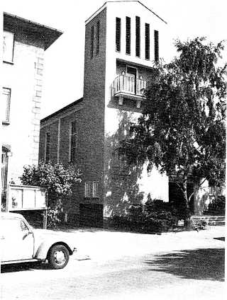

By courtesy and kind permission of Heinz Ebert

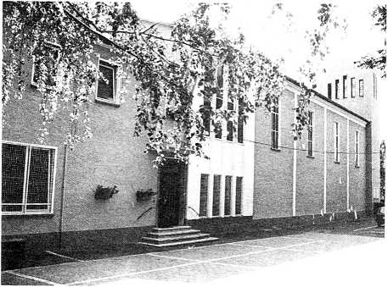

had a variety of craftsmen among our congregation. Everybody helped accord­ing to his skill and ability. The collabora­tion in this work between the Christians of various social and professional backgrounds—meanwhile singing and sharing their everyday life with one another—produced a fine community.

We were often reminded of the rebuild­ing of the city walls of Jerusalem under the prophet Nehemiah, where they all worked side by side with similar results.

When our simple church was finished, we all felt it was a part of us. Now every member started to invite non-Christian friends, as we now had room to seat them. Father held Gospel Campaigns and put extra emphasis on children’s and young people's work. Young people regularly fetched children from non- Christian families to children’s Sunday School, because the streets were not safe for children to go alone. So attendance at all the church’s activities grew rapidly, and after very few years this rebuilt sanc­tuary became too small. As things in Ger­many had improved much, the church members were in a position to enlarge and decorate the sanctuary.

Meanwhile a new vicarage had also been constructed, into which our family had moved.

Church life flourished: young people,

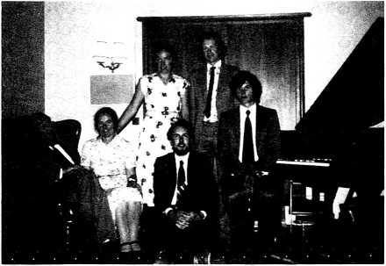

The author and her family.

old people, educated, and uneducated became Christians. A number of them became active and helped in the church and in their homes to win others for Christ.

My two sisters and I were also engaged in work among young people and chil­dren. Our church was one of the very few Bible-believing evangelical churches in Frankfurt—and Frankfurt is known as a very liberal and materialistic city. Formerly it was the seat of the Rothschilds’ financial empire, even though it had been very anti-Semitic before the Rothschilds’ time. Because our church was an active evangelical church, American Christians from the CJ.S. Occupation Authorities often joined in Christian fellowship with us. We helped and had fellowship with missions who came over to Germany after the war to start their work there and looked for contacts, such as the Navigators, Youth for Christ, and Child Evangelism.

After high school and graduation, my older sister, Rosemarie, started to study theology, 1 studied music, and Christiane studied interior architecture. During one year, 1950, we all became engaged to Christian young men.

**Chapter 10**

Reliving

Youthful

Memories

In the summer of 1980, my husband and I had the privilege of traveling in two eastern European countries. We used the opportunity to drive north and visit my old home town, Gollnow, where I had spent so many happy years of childhood. We were shocked when we got there.

The beautiful old house in which we had lived had disappeared without a trace and most of the old Hanseatic houses had experienced the same fate. In the place of the old houses, block upon block of most shoddy mass slums had been erected— on the foundations of the old houses.

My old primary school—where we had cared for the sick refugees—was still standing, but the high school was gone.

The same view to­day with the restored church tower.

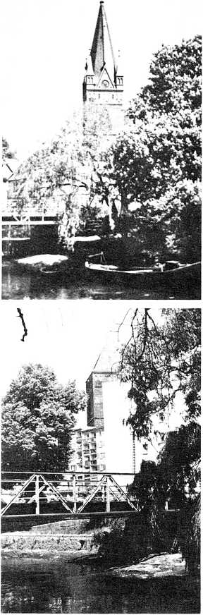

Gollnow:

The church before the war. The tower was damaged by artillery during the Russian siege.

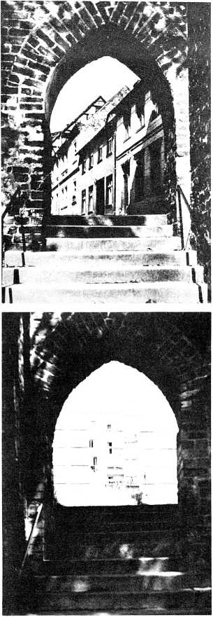

Another city gate before the war.

. . . and after the war today.

The church in which father served as a minister for many years had been pre­served, but was now Roman Catholic. The church tower had been partly shot away during the fighting and only provisionally repaired in a shortened form.

The city wall in all its old beauty was still standing, but the slums made a ridiculous contrast against it.

But the greatest shock of all has yet to be related. Mot only was not a single face in my home town recognizable, but the whole culture and language of my youth was gone, too. Mo one spoke a word of German, even the name of the town was transliterated into Polish. The streets had all been renamed and the empty shops had Polish inscriptions on them.

This was an entirely strange city to me and had nothing to do with my old child­hood world.

Unsuccessfully we tried to get a bed for our party for the night, but there was no room and certainly no food. After a long consultation between the eight of us on the street (one West German and five East Germans had traveled with us), we finally decided to try to find a transport camp. We drove quite a way out and eventually found a camp with one or two buses standing in front of it. On entering, the proprietress greeted us kindly, and— wonder of wonders—even in German.

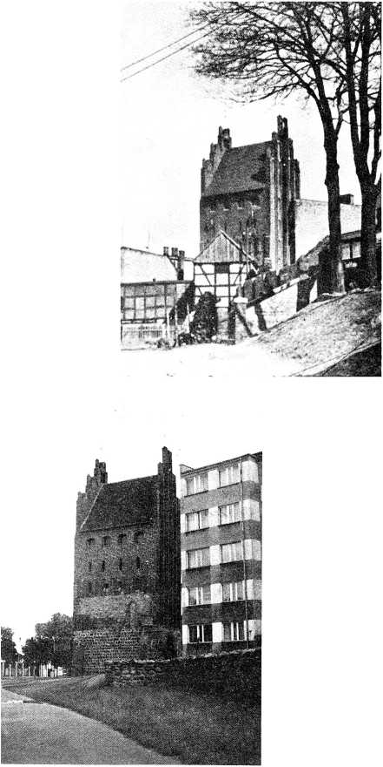

Gollnow: The city gate before the war.

Gollnow: The city gate now.

She busied around and produced from secret doors an excellent meal for all eight of us. It consisted of vegetable soup, fish, bread, and some Polish delicacies. Afterward some of the East Germans, who had accompanied us on this journey, got out their guitars and we all sang spirituals. The proprietress liked this, but said the communists didn’t, so would we please wait until all the other guests had gone and the door was closed. We did. Afterward one of our West Ger­man friends went into the back office with the good lady and her husband and presented her with some new shirts and chocolate candy. Her eyes lit up at this— you can take anything into Poland as long as you leave it there. Our Polish friends were absolutely delighted and put us up in neat little timbered huts for the night.

The next morning, after having washed in an open general bathroom for all and with very little water and primitive sanitary arrangements, the good lady treated us to a breakfast which was sump­tuous for the Poles, but for us westerners just sufficed to keep body and soul together. It was Whit Sunday and our West German friend and host packed the rest of his presents (brought with him from West Germany) and presented them as a Whitsuntide gift to the proverty- stricken East German friends, all things they never can buy in their shops: coffee, chocolate, candy bars, special foods, etc. We all stood under the trees in the woods and sang a Whitsuntide hymn and doled out the presents. My husband had to give a little address, followed by a prayer. It was a most unusual Whitsun service, everyone standing in the woods with no church.

But the greatest surprise comes last. We went to pay our bill, which meant a solemn conclave between the pro­prietress and our West German host. Nobody saw these deliberations—not even we. But two beaming faces emerged after a period of tense waiting—we did not know whether or not we had enough money for such luxuries as we had en­joyed. Now came the supreme moment: the bill was 25 DM (= Cl.S. $11) for all eight of us, including a sumptuous (for Poland) evening meal, 8 beds in 3 block huts, and breakfast, we making no charge for the evening guitar concert. Everybody was delighted and we pro­ceeded on our way to the rigors of another inspection on crossing the Polish-East German frontier.

However, our Mercedes and the East German Wartburg are both thirsty customers and need gasoline. We had to stop at garages to try to get some of this

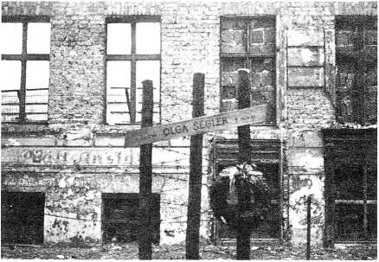

The Benauer Street in Berlin which is the frontier be­tween East and West Berlin. At the point shown an 80-year-old woman was shot dead by East German police as she tried to escape the Soviet terror. She jumped out of the window on the eastern side to reach the street on the western side. As she fell she was shot.

material. My husband did not risk calling it gasoline because it had an octane rating of about 70 and our motors pro­tested against such insults. Hardly had we stopped at one garage when a sinister figure sidled up to my husband and whispered that he would give him a lot more East German currency than that allowed by the official rate for some gen­uine West German marks. Fortunately my husband had been warned: the sidling figure would probably have turned out to

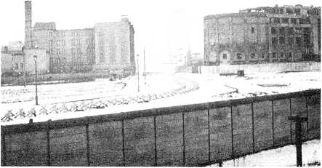

The infamous Berlin Wall erected by the Soviets from materials bought in the west. It is about 100 yards wide and is mined. It is sealed with barbed wire and concrete emplacements, together with booby traps which shoot automatically the unwary.

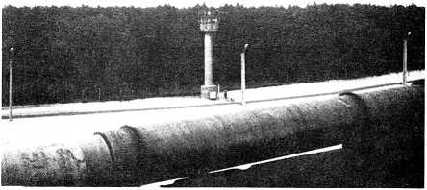

Another view of the Berlin Wall taken from the western side showing the watchtowers on the eastern side. A soldier is on patrol on the eastern side.

be a government informer who would then have arrested us for contravening communist currency regulations. The pressure of spying and informing is very great in all the east so that one is glad to get over the frontier and breathe free air once more.

But another shock awaited us: we had been forced to buy sloties and East Ger­man marks, but no garage would accept them to fill up a western car with gasoline. Gasoline cost at that time about 70 pfennigs per liter in West Germany. We had to pay in West German marks in Poland 2 DM for a liquid which passed as gasoline. Under the communist currency laws the East Germans and the Poles are not allowed to buy western currencies. But here we found a state-owned garage doing that which is forbidden for the or­dinary civilian, namely buying western currency.

In Poland and in East Germany we met active groups of evangelical Christians who still stand firm and suffer bitterly for it. Often their children are not allowed to study in universities or occupy better state or civil positions. But the hunger for God’s word and for Christian fellowship is very great. The position of the few evangelicals in Poland is aggravated by their being a small minority under a rul­ing state church.

Chapter 11

Outlook

Recently my husband and I took part in a seminar for professors: scientists, philosophers, and theologians. In the course of the conversation, one scientist suddenly asked the question: ‘‘Do you believe in a personal Devil?” First he ad­dressed one of the theologians. “Mo,” the theologian answered, “1 do not believe in a personal Devil. There is no evidence for it. I believe in good and evil. Only primitive people imagine personified good and evil.” Mow the same question was put to my husband, a natural scien­tist. He answered in the affirmative, he believed in a personal Devil. Then a philosopher, a dear lady professor, said the following: “When I was a girl of about 10 years old, we had neighbors who were very decent people. The Mazis came to power and started spying on everyone. Suddenly our neighbors became

changed people in a matter of a few weeks. They began to denounce their neighbors in the village and brought a number of them into concentration camps, all simply in the intent of their own promotion in the ranks of the Nazis. They appeared to have become pos­sessed by evil powers”—or so it seemed to the lady professor as a child. “They were different persons from what they were before: I think evil can certainly be personified.”

Many people today look with astonish­ment at the history of Germany and cen­tral Europe and express the conviction that such could never happen again — either in Europe or in other countries. All the experiences through which people have been have taught them, so they think, a final lesson personally and politically. Not necessarily so!

Some time ago my husband was con­fronted during a program on the South German TV network entitled “How to Form Public Opinion,” by the question whether he thought that Germany would ever fall into Nazism or something similar again in the future. He replied: “The fact that German public opinion is being manipulated daily in favor of socialism scarcely distinguishable from communism proves the point. Germany is falling into exactly the same trap again.

The great secret of the avoidance of dic­tatorship in a people not predominantly evangelical lies in unbiased public infor­mation. The present news systems in the western world, be they political or scien­tific, are highly biased in favor of materialism, which will never give the people the strength of character necessary to prevent a recurrence of totalitarianism, which is as natural to man (that is to non-Christian, carnal man) as breathing. It lies in us, that is in the natural man, to be totalitarian—even in our Christian and democratic organiza­tions we have to beware of it. Only the liv­ing Christ, through His living Word, is capable of changing a man’s heart so as to prevent the victory of the natural man as seen in brown fascism and red com­munism. Every man is capable of every­thing—of Hitler's or Stalin’s works in thought and deed, or, in contrast, of the works of the Spirit of God in thought and deed—depending on which spirit we dai­ly give our heart to.’’

The secret of stopping a recurrence of totalitarianism lies in the ability of the political and religious leaders, as well as the "grass roots,” not to seek for absolute power for personal purposes, but to realize that each individual is an ad­ministrator and executive for Christ on earth and is responsible before Him for

himself, his community, and his environ­ment.

As long as mass media are at enmity to that principle and the people listen to this maleducation instead of God’s advice through His word, there is not much hope of stopping the rapid arising of new tyrannies.

Preventing history from repeating itself can only be accomplished if a large percentage of the people and the leaders possess Christ’s mind through His spirit and close discipleship. The more that people in important positions arrange their lives, as well as influence those of their nation, in accordance with the will of God, the greater the possibility that history will not repeat itself. All of us have to work actively toward this goal.

History will repeat itself if we either forget it or do not know it and its lessons.

**Books By**

**A. E. Wilder-Smith**

Ph.D., Dr. es Sc., D. Sc., F.R.I.C.

Available From

MASTER BOOKS

A Division of CLP Publishers  
P. O. Box 15666  
San Diego, California 92115

**Creation of Life**

Evaluates the practicing evolutionist's ex­perimental design and data. Points out that scientific materialism hold the key to neither man’s origin nor his destiny. Emphasizes that in order to have an efficient design, you must first have an efficient designer. No. 039

**Man’s Origin, Man’s Destiny**

Where did we come from . . .and where are we going? Both of these questions have in­trigued mankind since the beginning of time. Dr. Wilder-Smith covers the entire spectrum of existence in this fascinating and com­prehensive study which extends from the beginning of life to man’s ultimate step into eternity! No. 101

**The Natural Sciences Know Nothing of Evolution**

Examines the evidence and presents the con­clusions in a comprehensive analysis of evolution from the viewpoint of the Natural Sciences. Recommended for teachers and college students, as well as laymen with a special interest in the study of origins.

**No. 110**

**He Who Thinks Has To Believe**

Explores the marvelous process of reasoning and drawing logical conclusions, with the result that anyone who uses these natural abilities of the mind properly, must arrive at the conclusion that there is a Creator-God.

**No. 077**

**Why Does God Allow It?**

If there is a God—who is supposed to be "good'' and loving—why does He permit all the violence and suffering in the world? Does the abundance of evil prove He really doesn't exist? Sensible answers to questions that have plagued people since the beginning. Gripping photos. No. 186

